The Transfer Function of the plant will be represented in the Simulink models as:

1. Proportional Controllers
2. Draw a block diagram to represent the unity feedback control system when plant is controlled by a cascade proportional controller.

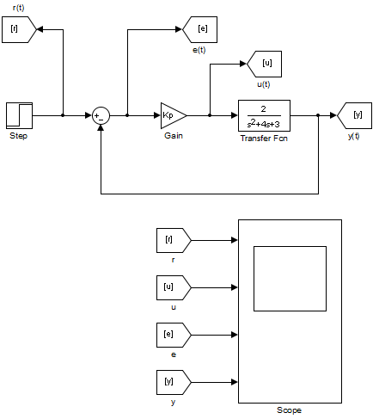

Figure 1.1. Proportional Controller Model.

1. The following figures represents the system response using a Proportional Controller with different gain values and no disturbance, setting the System Input as a unit step.

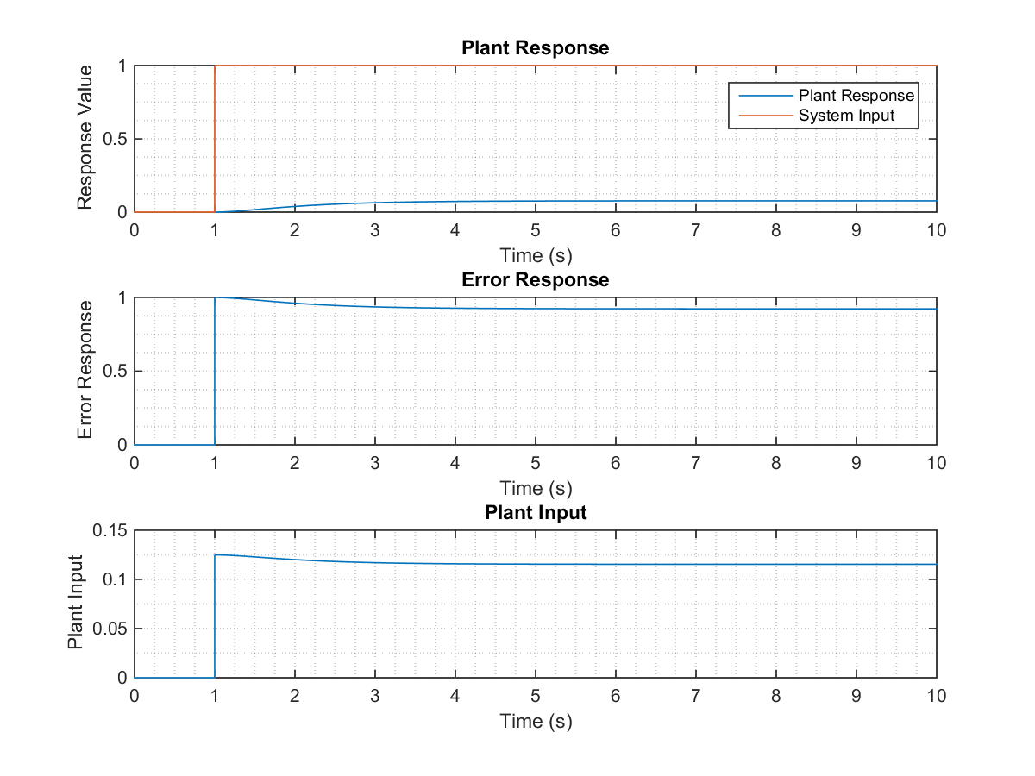

Figure 1.2. Parameters response for Proportional Controller with Kp = 0.125.

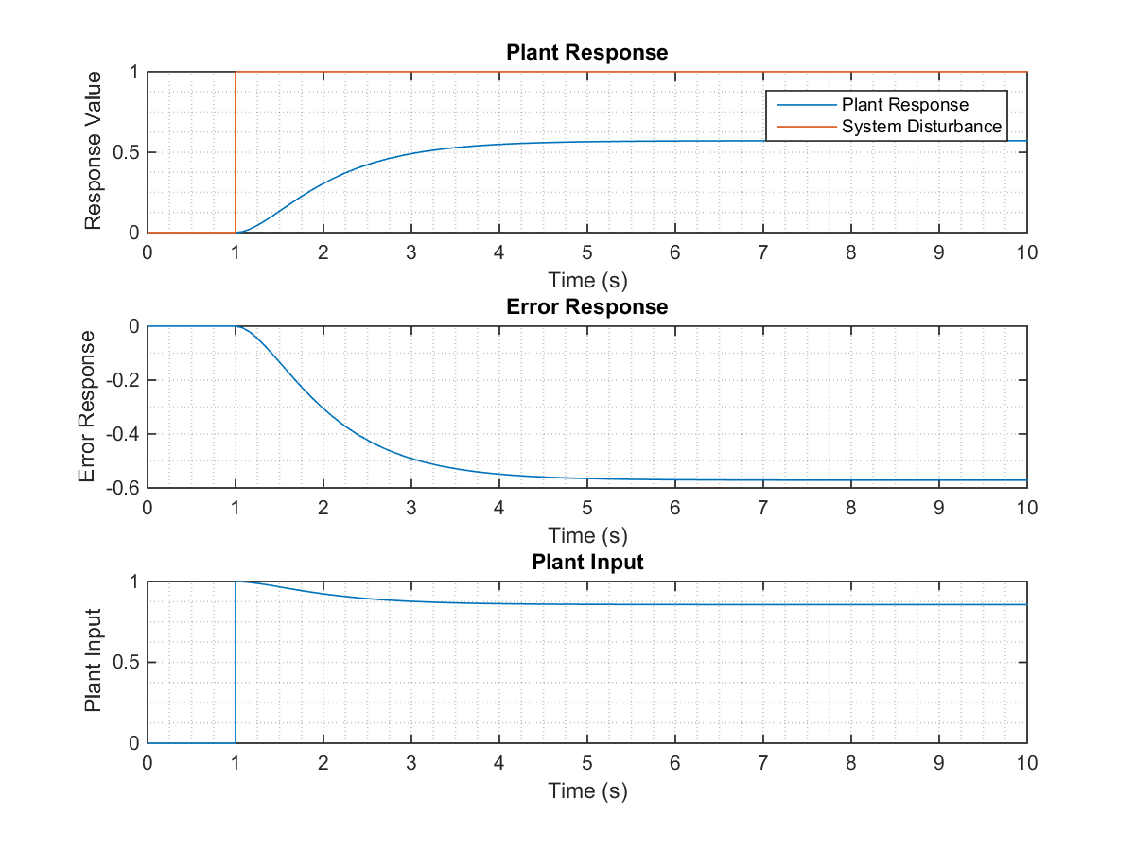

Figure 1.3. Parameters response for Proportional Controller with Kp = 0.25.

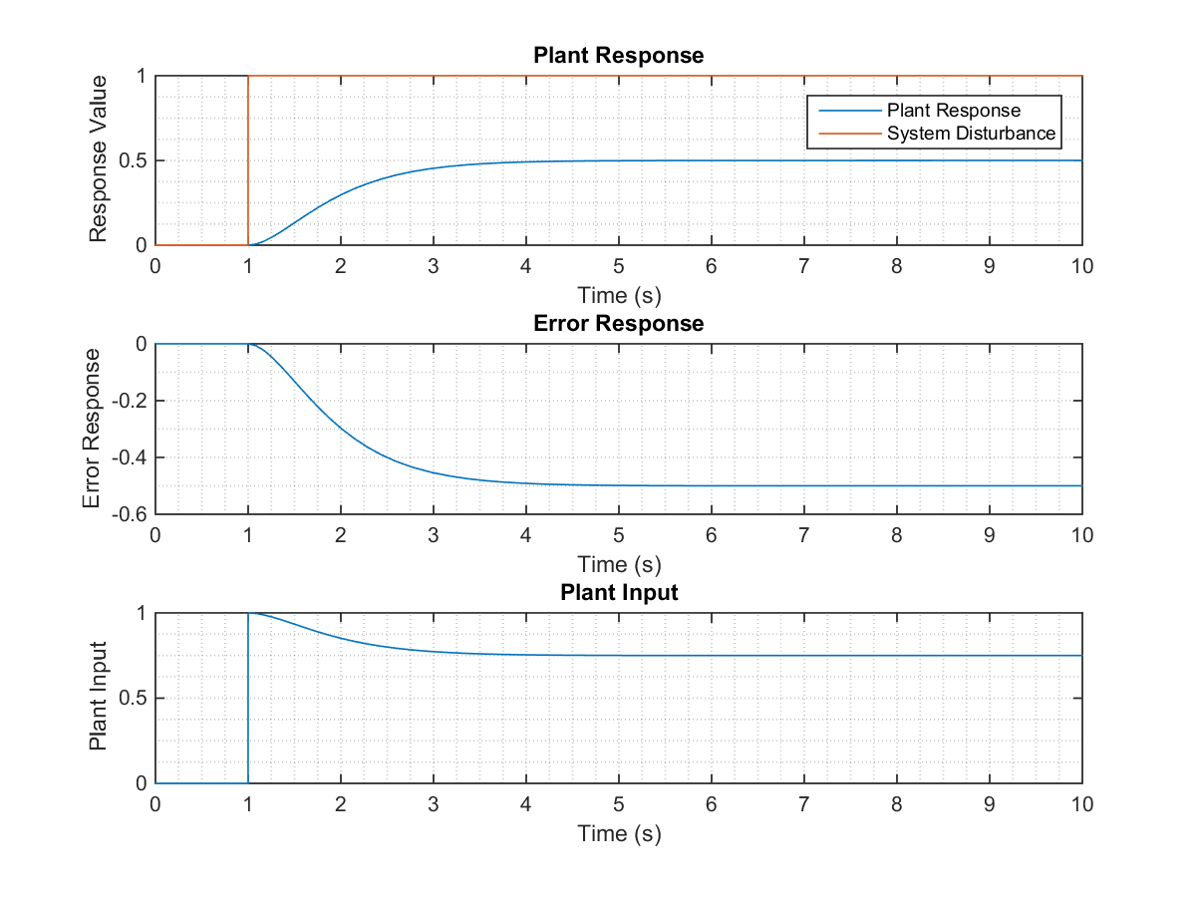

Figure 1.4. Parameters response for Proportional Controller with Kp = 0.5.

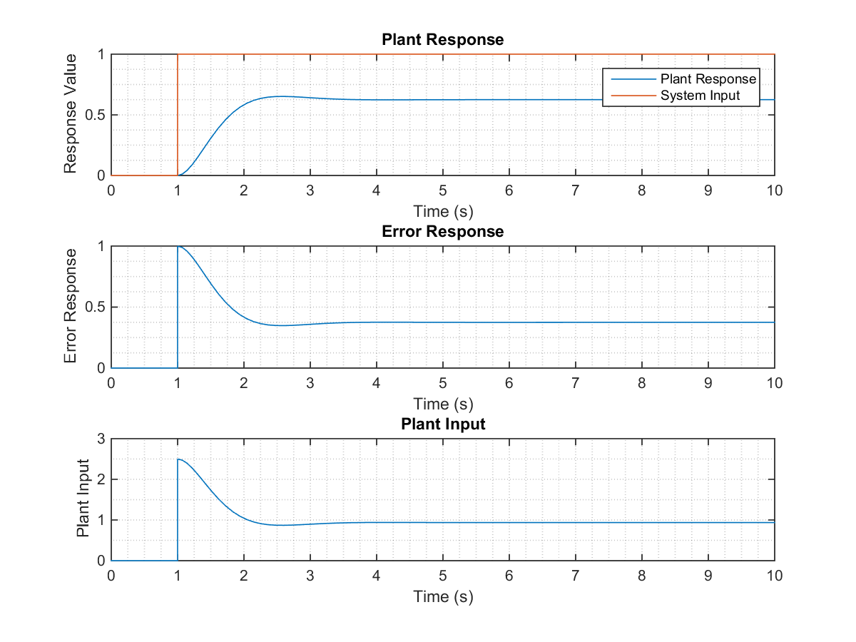

Figure 1.5. Parameters response for Proportional Controller with Kp = 2.5.

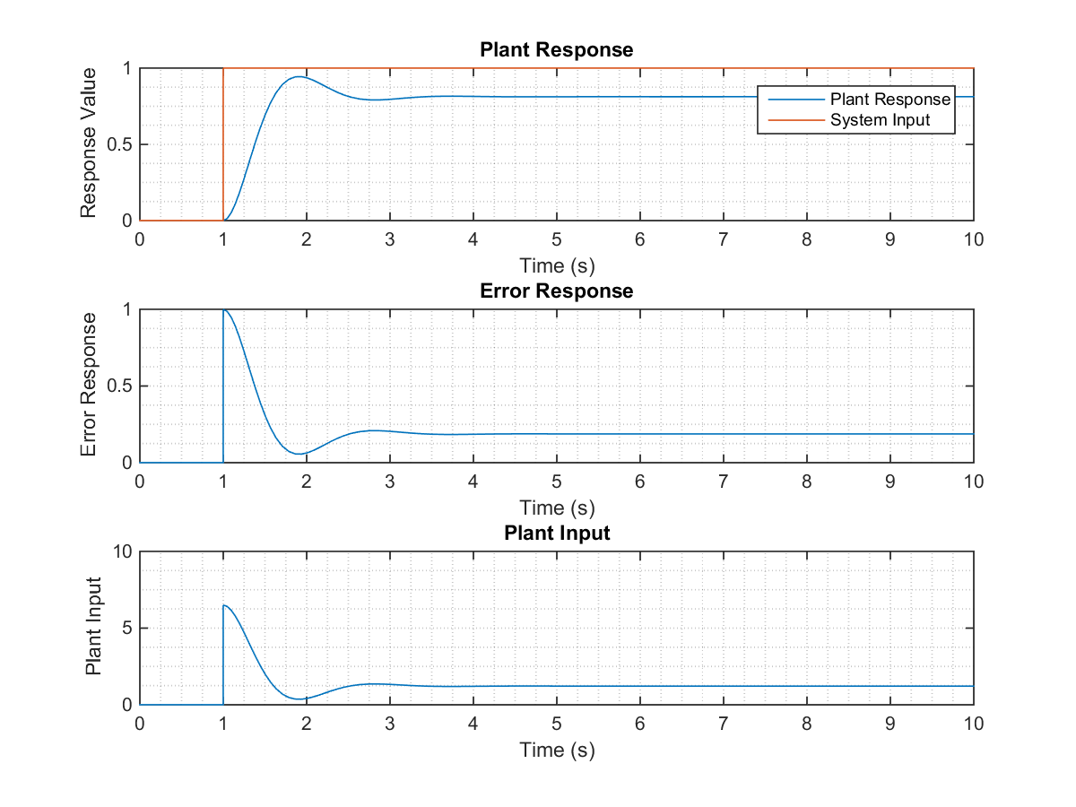

Figure 1.6. Parameters response for Proportional Controller with Kp = 6.5.

1. The following figures represents the system response using a Proportional Controller with different gain values and no system input, using disturbance as unit step.

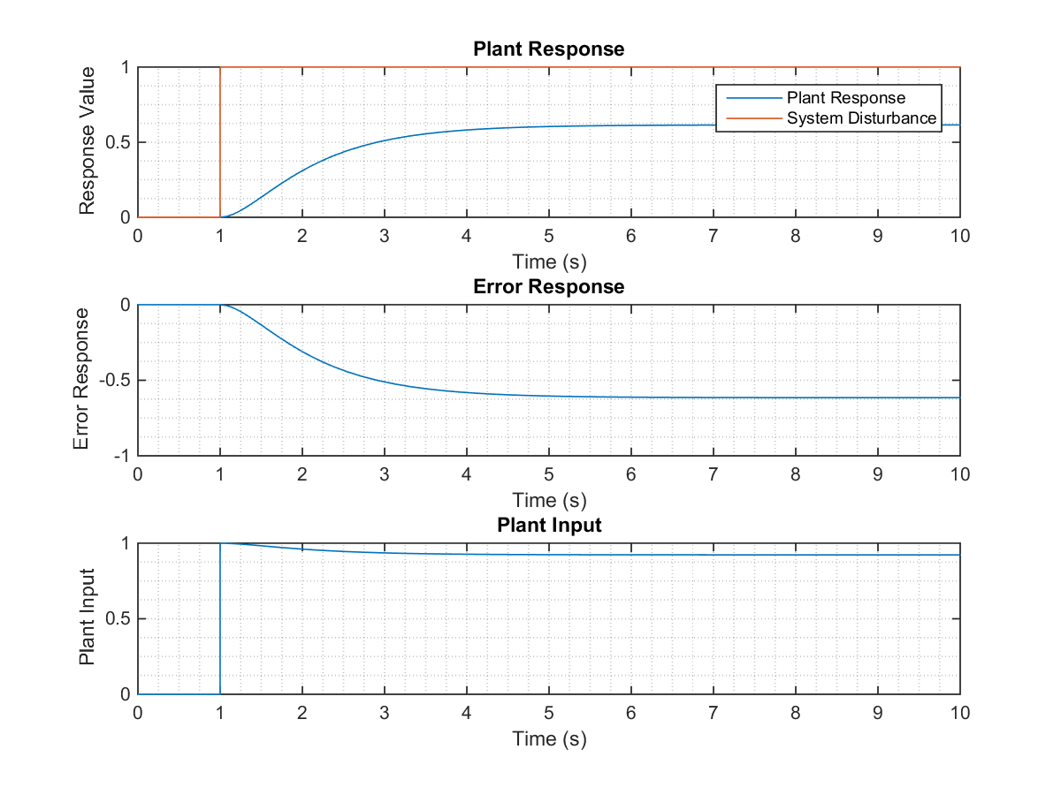

Figure 1.7. Parameters response for Proportional Controller with Kp = 0.125.



Figure 1.8. Parameters response for Proportional Controller with Kp = 0.25.



Figure 1.9. Parameters response for Proportional Controller with Kp = 0.5.

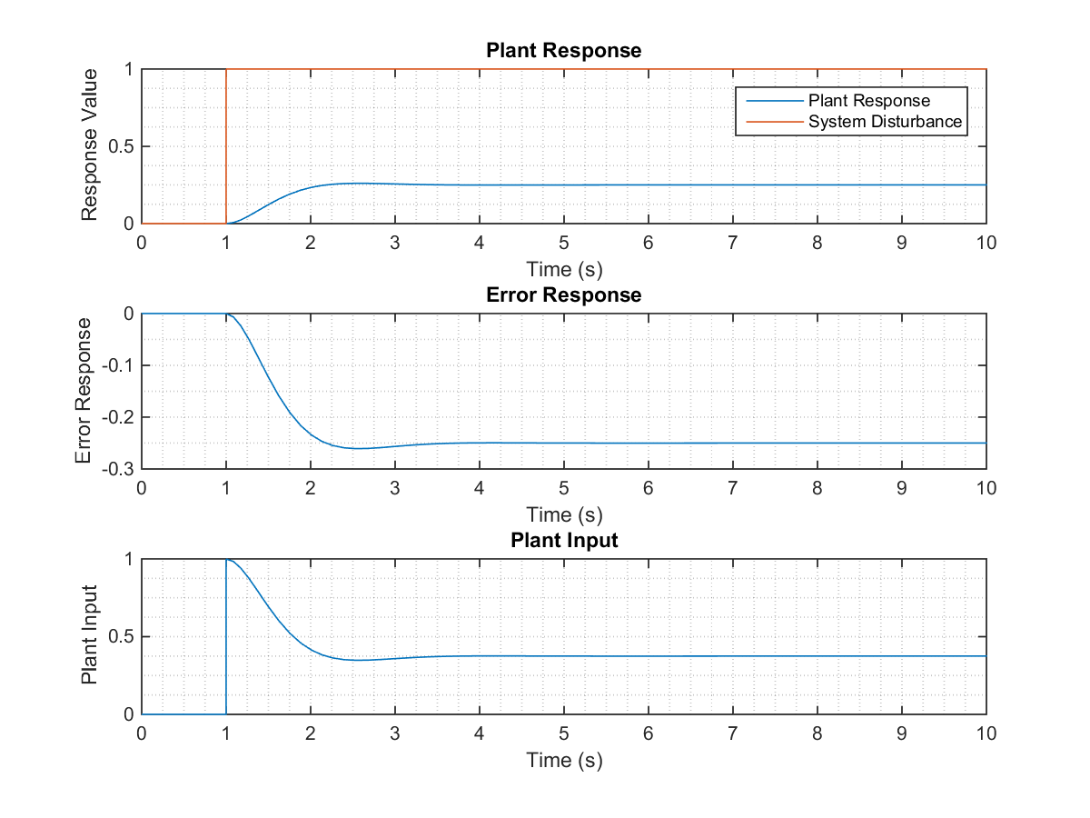

Figure 1.10. Parameters response for Proportional Controller with Kp = 2.5.

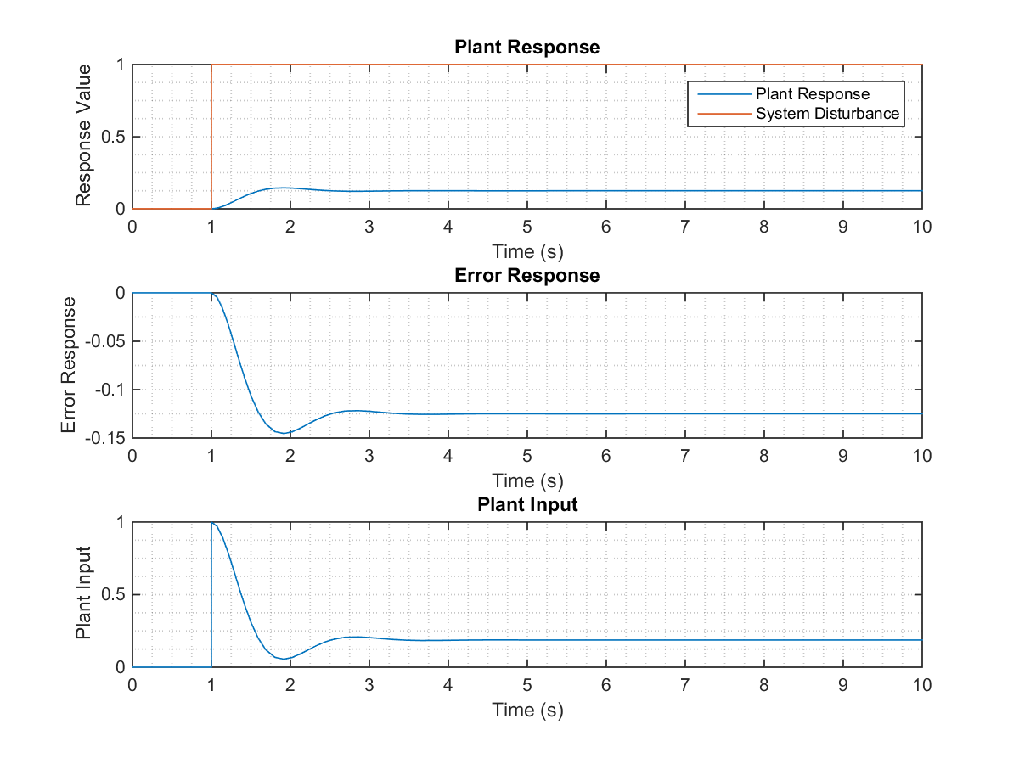

Figure 1.11. Parameters response for Proportional Controller with Kp = 6.5.

1. Integral Controllers
2. Simulink model to control the plant by Integral Controller.

The Transfer Function for the Integral Controller is defined as:

The Simulink model used to simulate the Plant controlled by an Integral Controller is presented in the next figure:

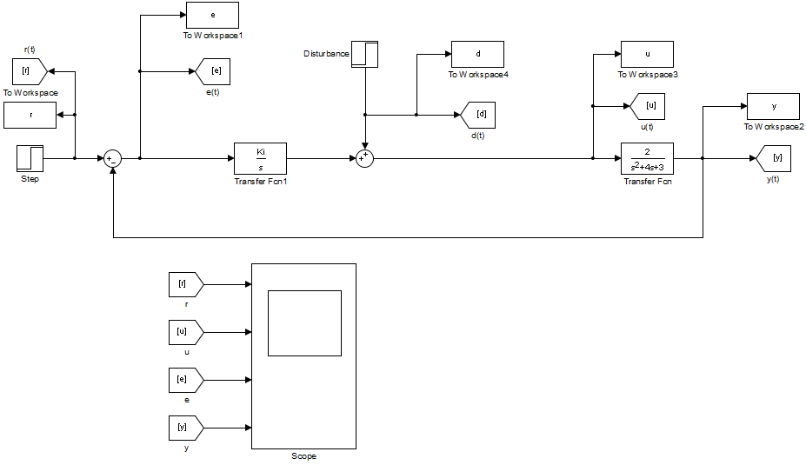

Figure 2.1. Simulink model for plant controlled by Integral Controller.

1. The following figure presents the System Response for different values of the integral controller gain, no disturbance and system input as unit step.

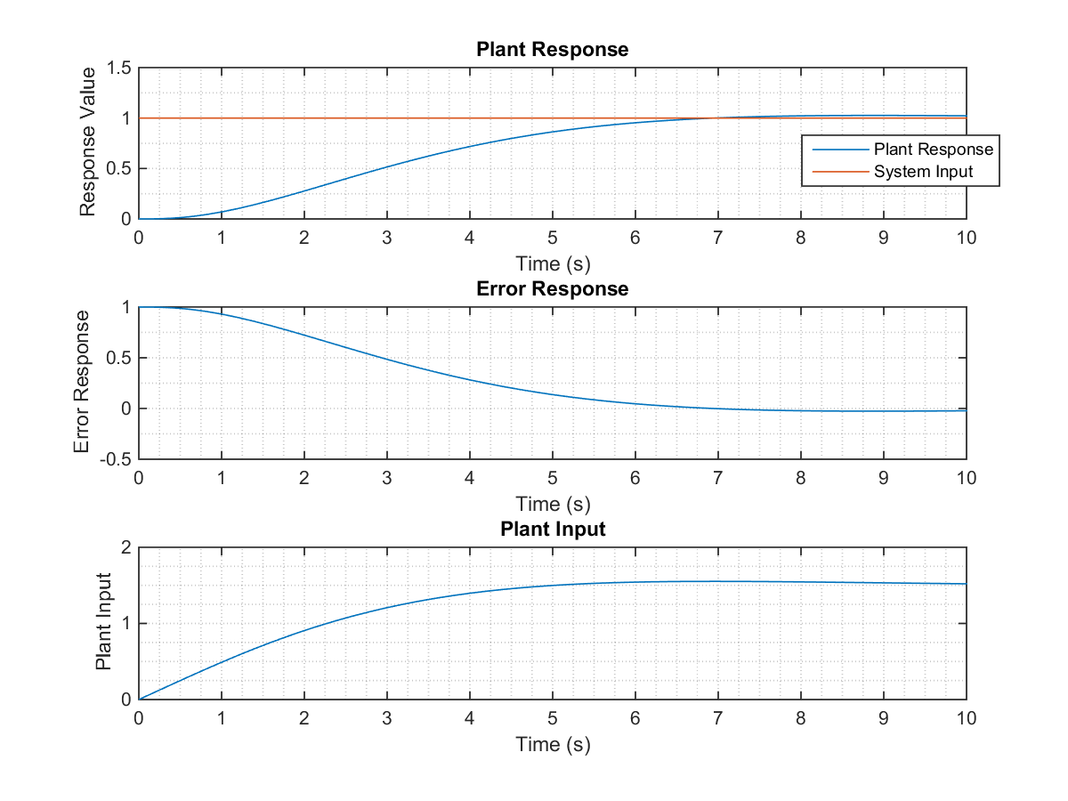

Figure 2.2. Parameters response for Integral Controller with Ki = 0.5.

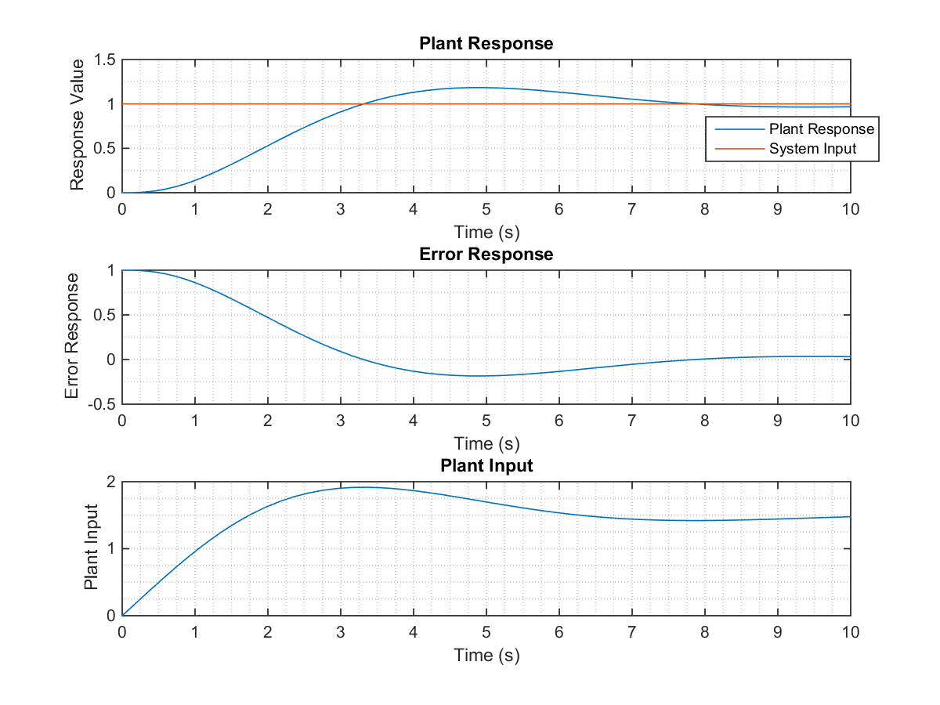

Figure 2.3. Parameters response for Integral Controller with Ki = 1.

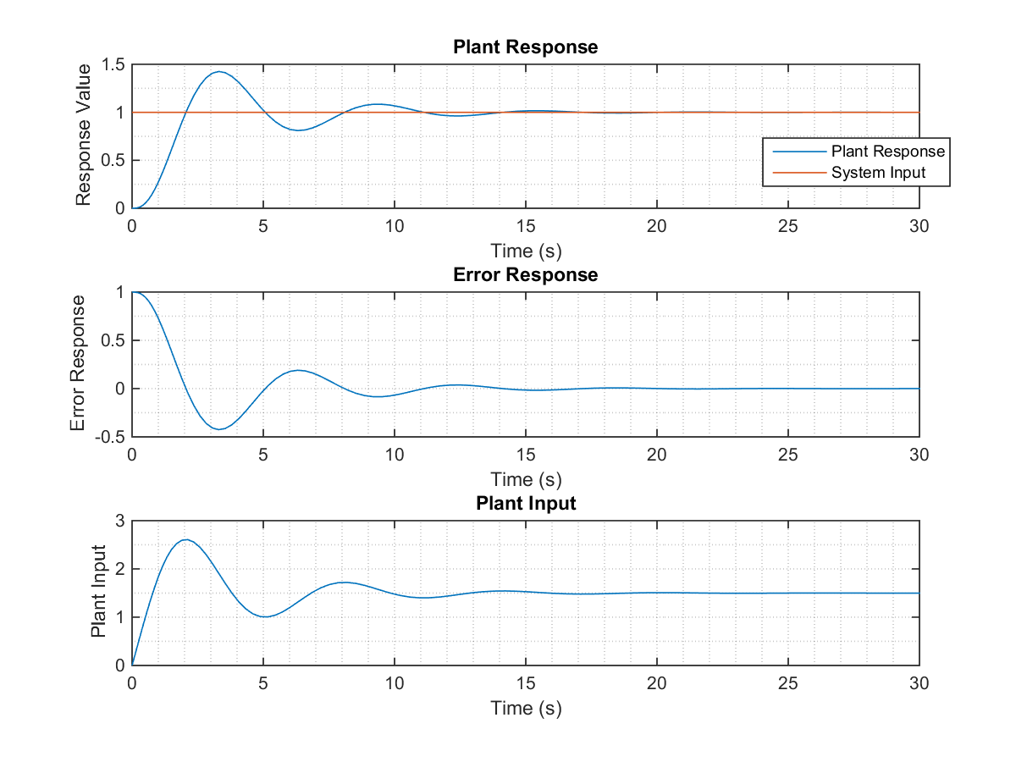

Figure 2.4. Parameters response for Integral Controller with Ki = 2.

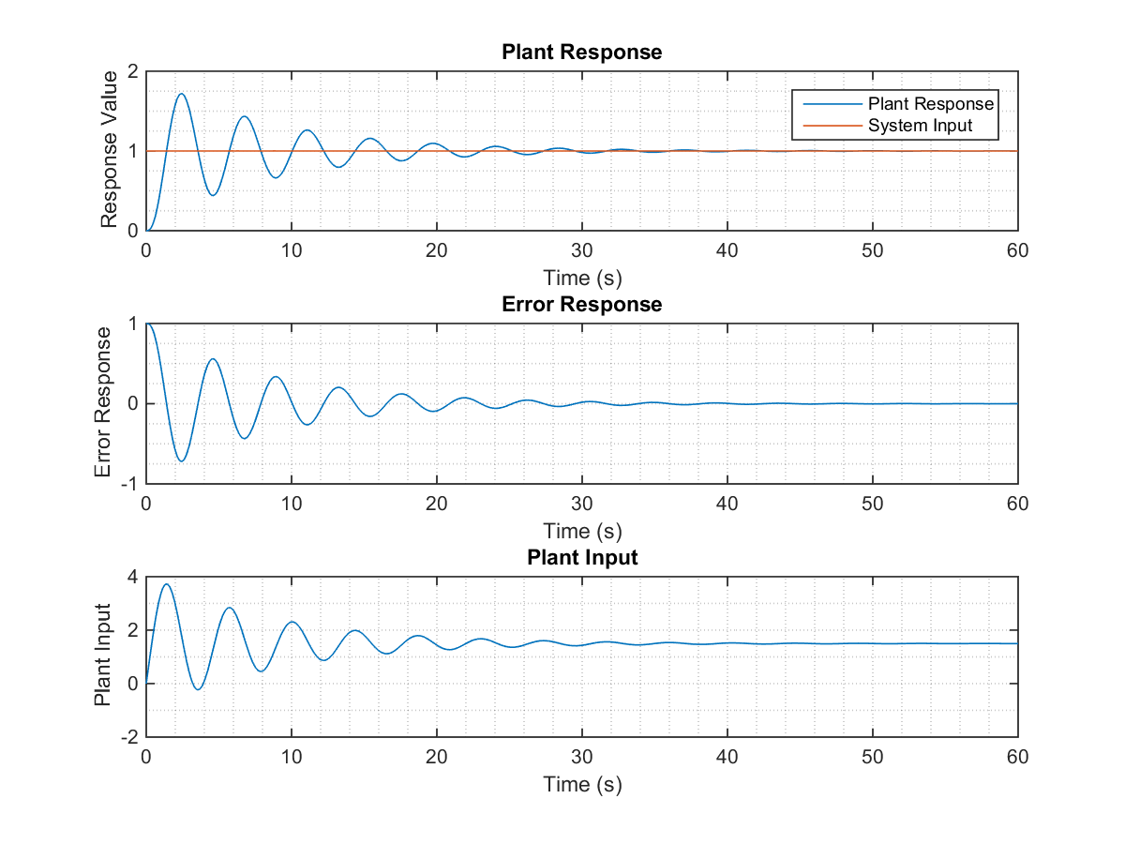

Figure 2.5. Parameters response for Integral Controller with Ki = 4.

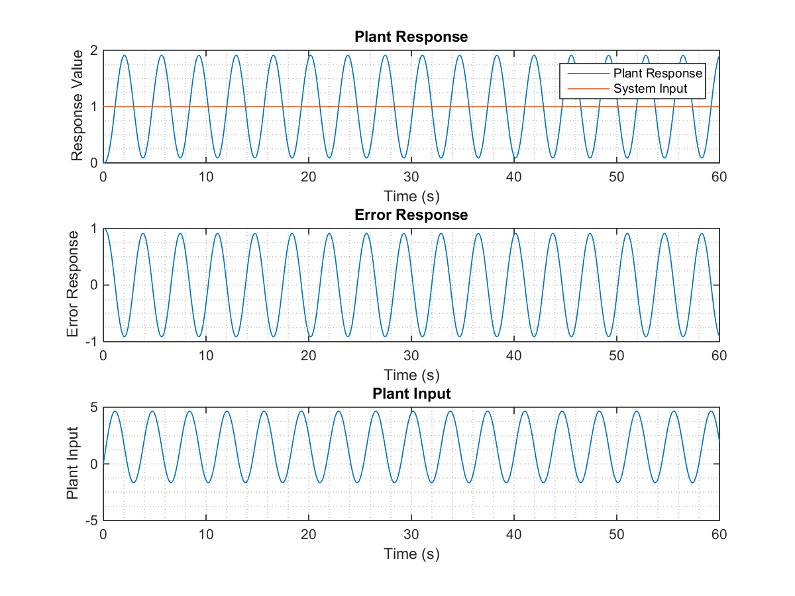

Figure 2.6. Parameters response for Integral Controller with Ki = 6.

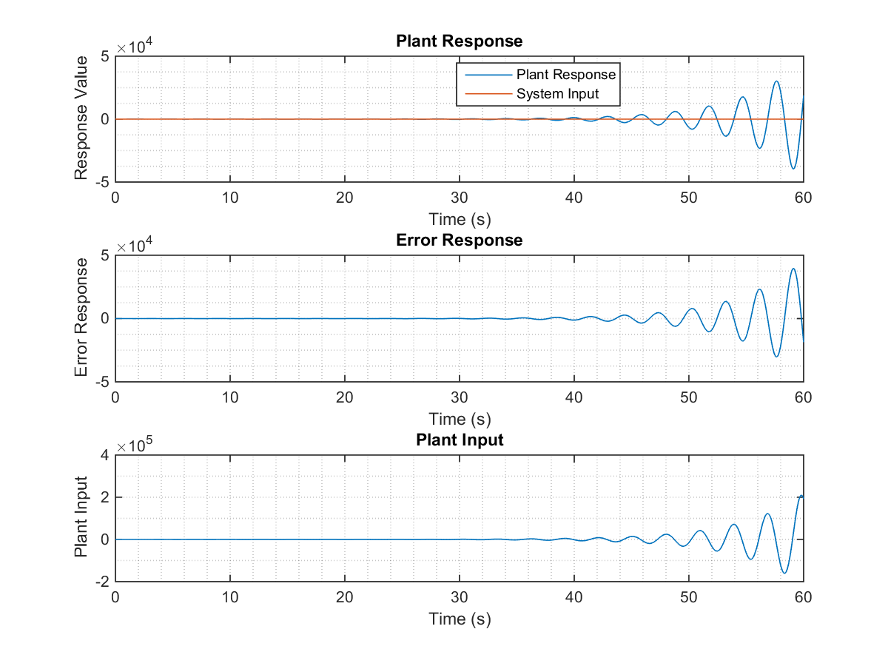

Figure 2.7. Parameters response for Integral Controller with Ki = 10.

1. The following figure presents the System Response for different values of the integral controller gain, no system input and system disturbance as unit step.

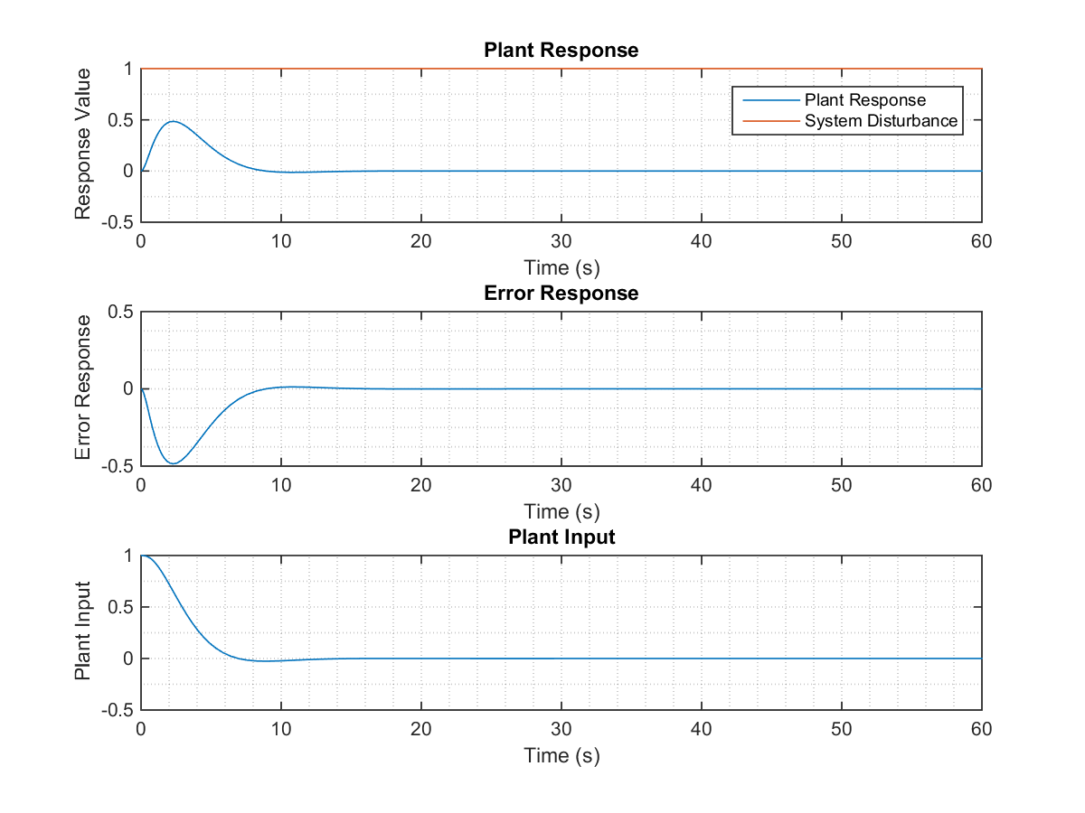

Figure 2.8. Parameters response for Integral Controller with Ki = 0.5.

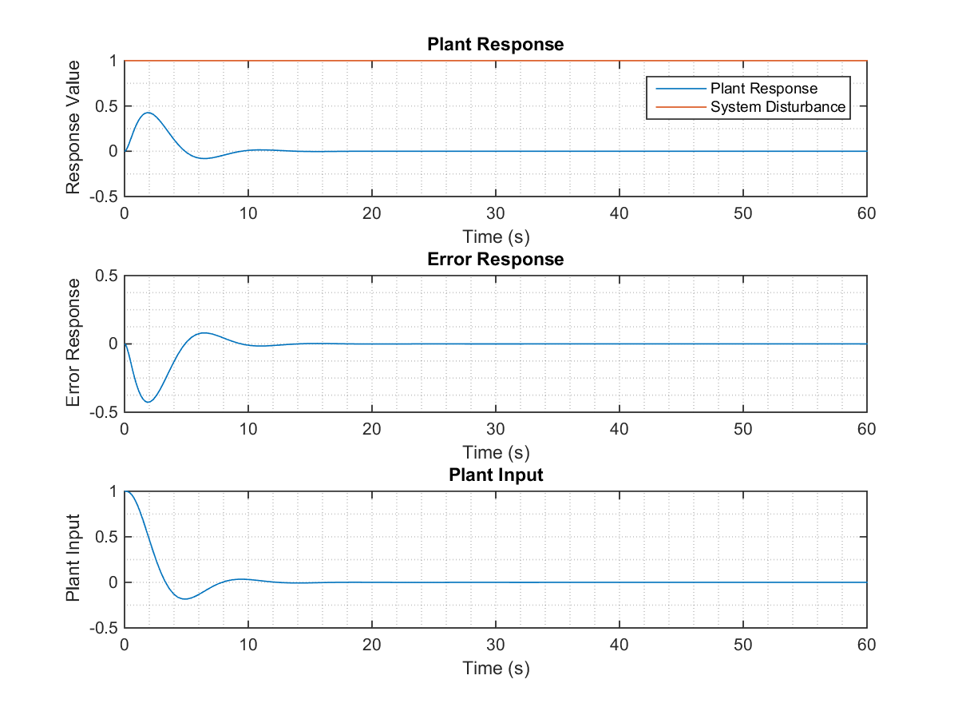

Figure 2.9. Parameters response for Integral Controller with Ki = 1.

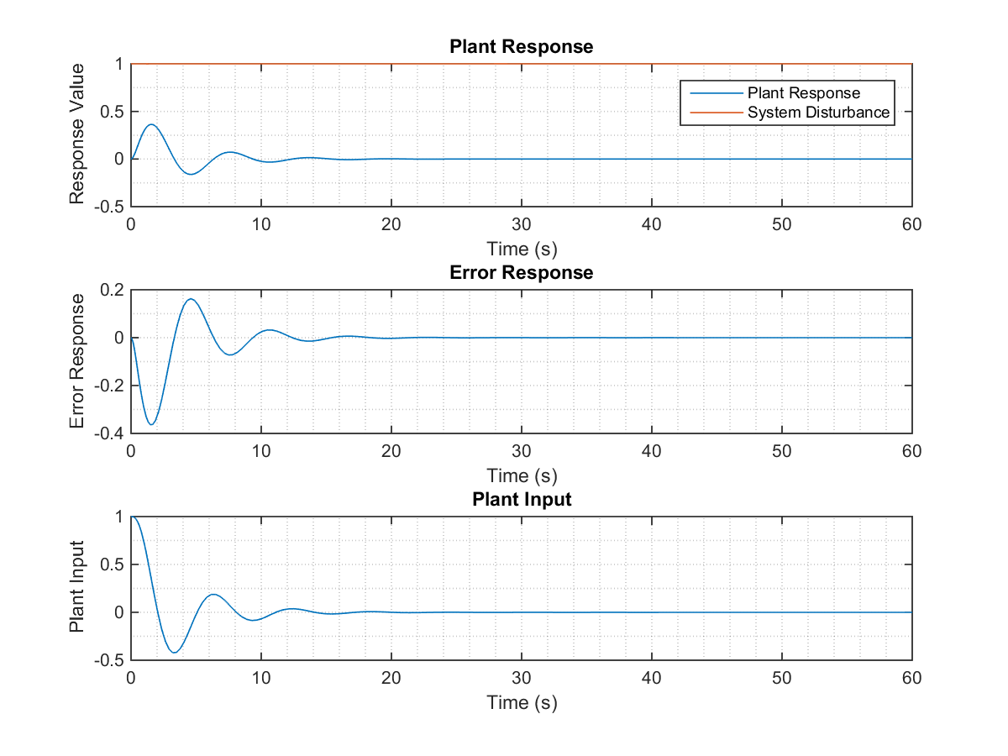

Figure 2.10. Parameters response for Integral Controller with Ki = 2.

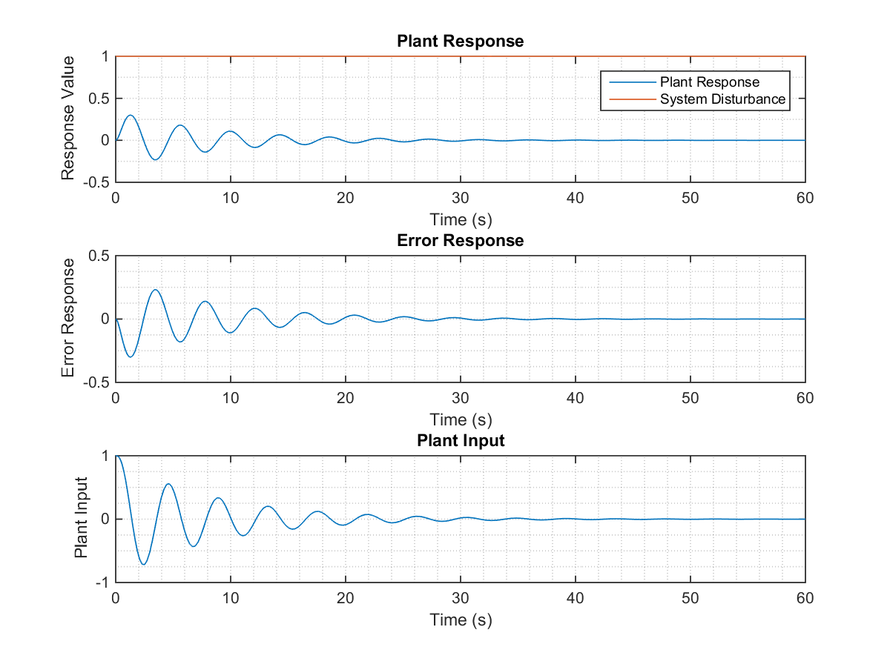

Figure 2.11. Parameters response for Integral Controller with Ki = 4.

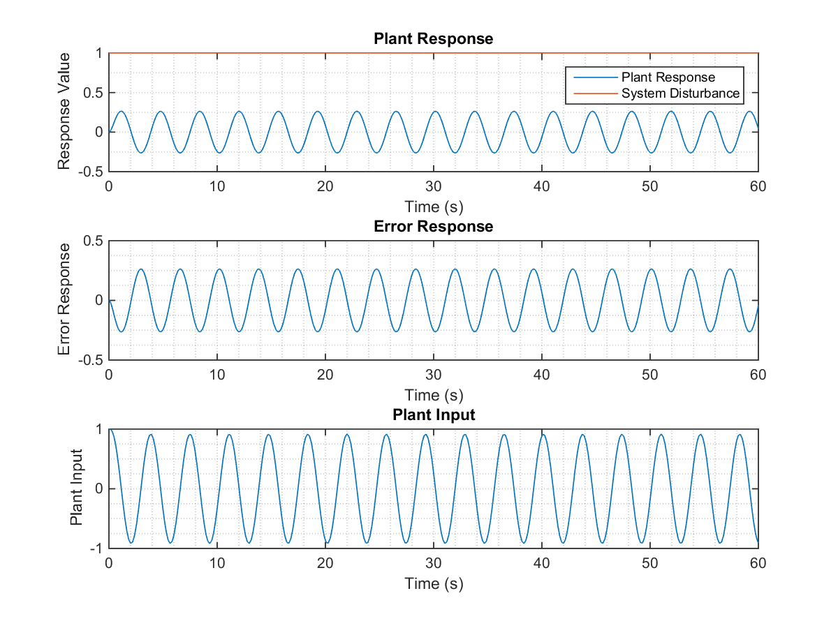

Figure 2.12. Parameters response for Integral Controller with Ki = 6.

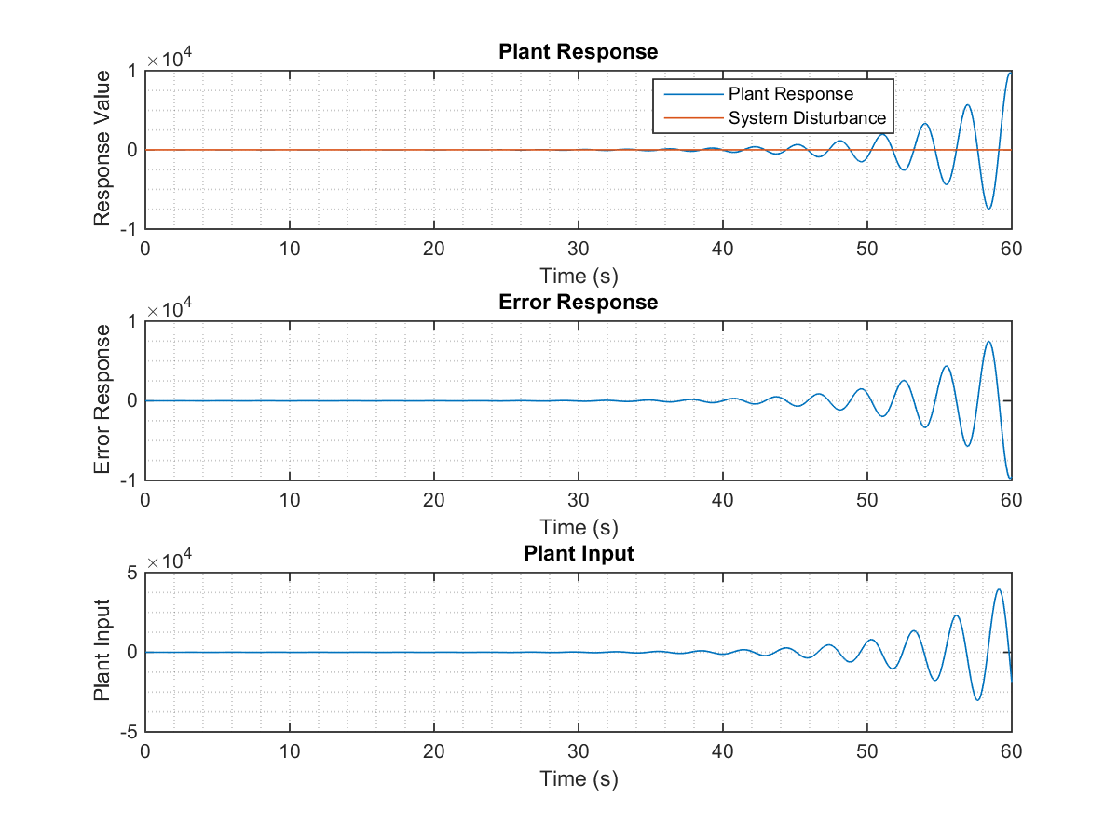

Figure 2.13. Parameters response for Integral Controller with Ki = 10.

1. Proportional and Integral Controller.
2. Simulink model to control the plant by using a Proportional Integral Controller.

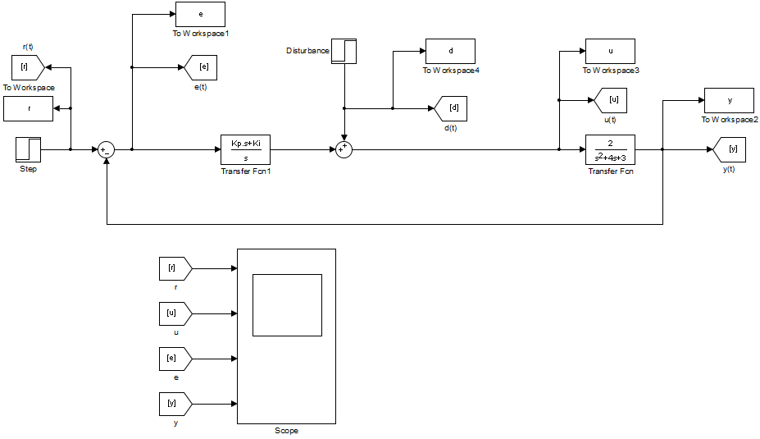

Figure 3.1. Simulink model for plant controlled by Proportional Integral Controller.

The transfer function defined by a proportional integral controlled used in the Simulink model is expressed as:

Where and are the proportional and integral gains respectively.

1. The following figures present the plant response for different values of and , with no disturbance and system input as unit step.

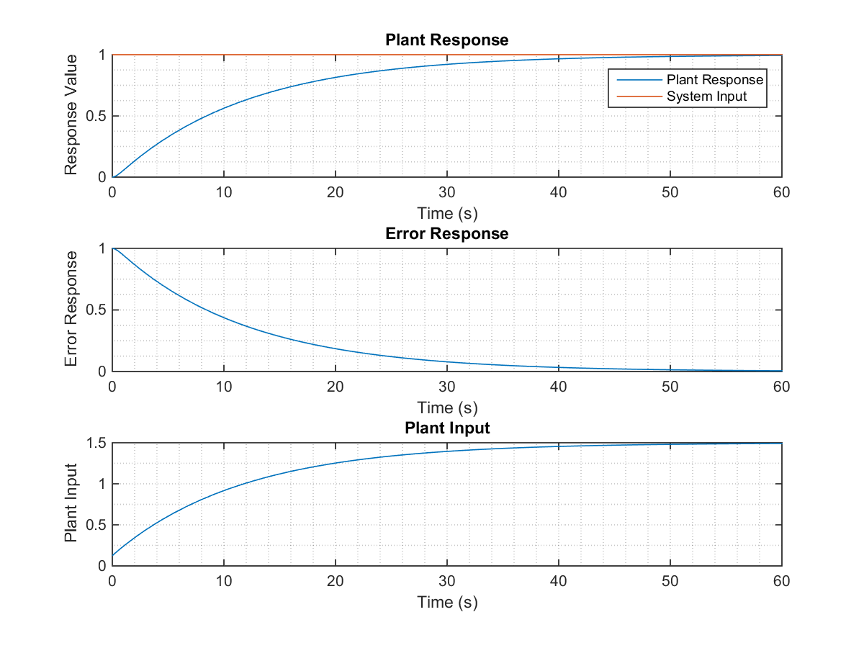

Figure 3.2. Parameters response for Proportional Integral Controller with Ki = 0.125.

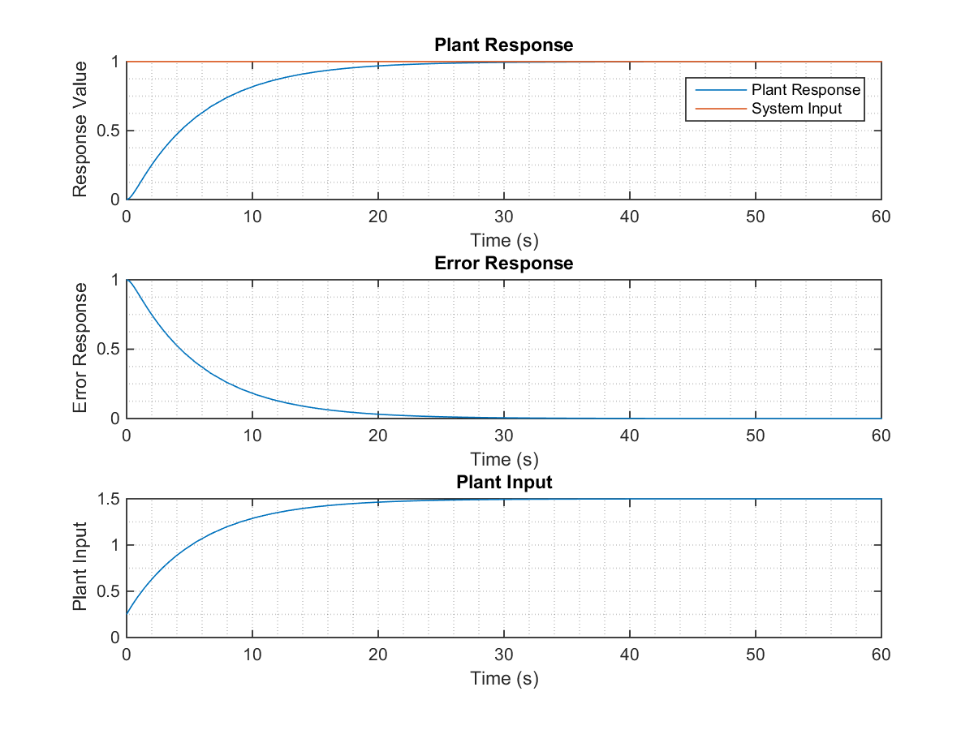

Figure 3.3. Parameters response for Proportional Integral Controller with Ki = 0.25.

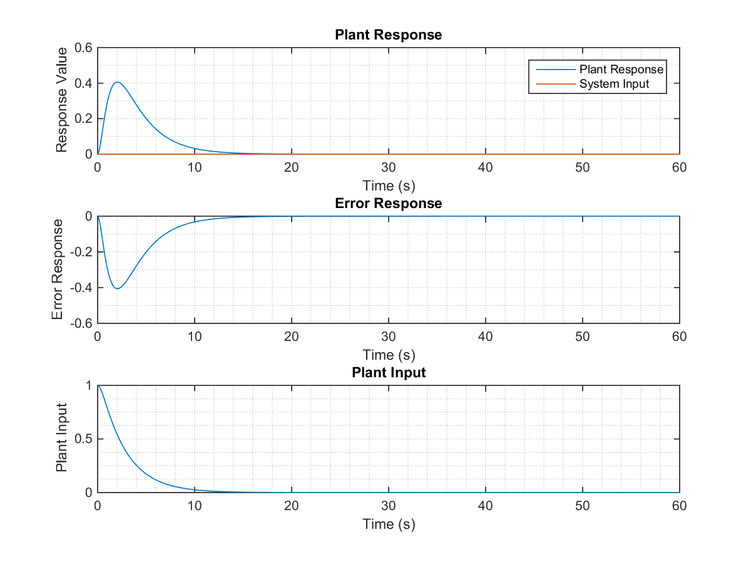

Figure 3.4. Parameters response for Proportional Integral Controller with Ki = 0.5.

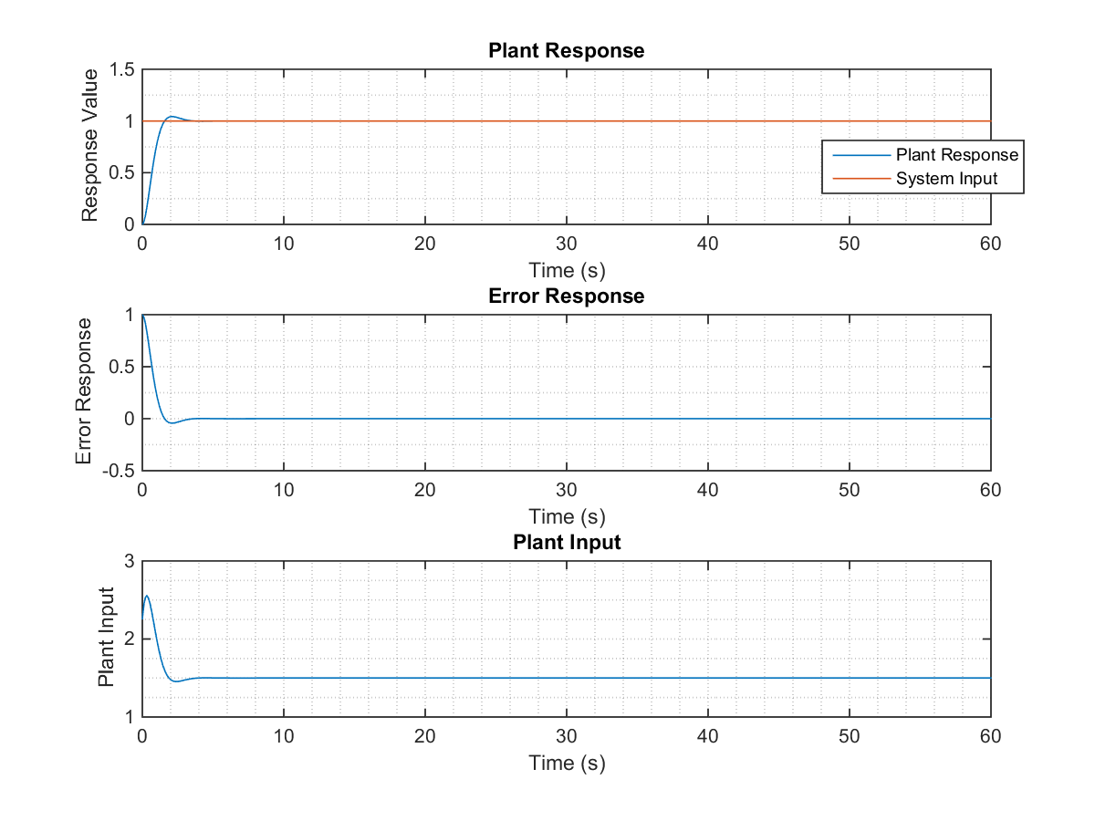

Figure 3.5. Parameters response for Proportional Integral Controller with Ki = 2.25.

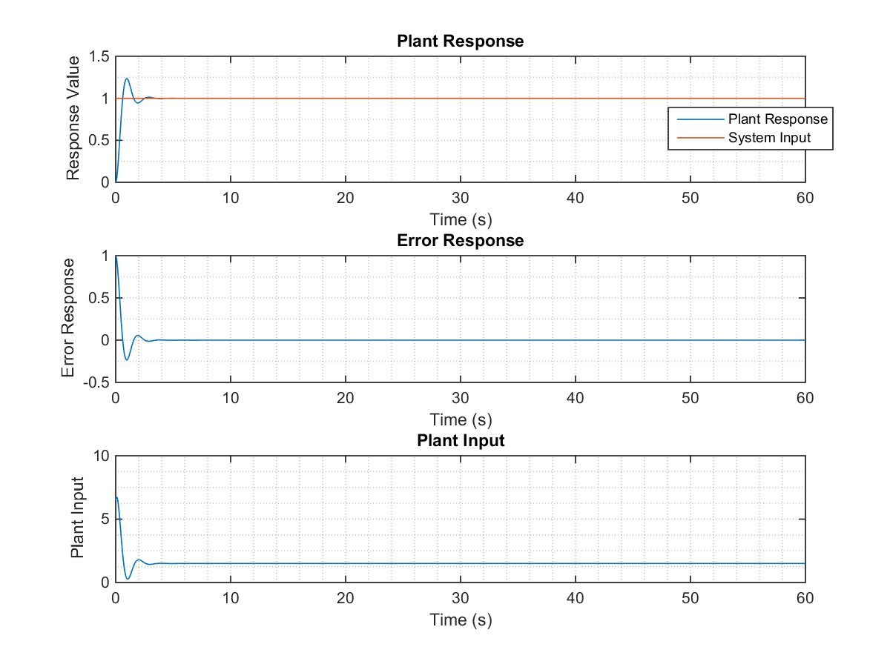

Figure 3.6. Parameters response for Proportional Integral Controller with Ki = 6.5.

1. The following figures present the plant response for different values of and , with no system input and system disturbance as unit step.



Figure 3.7. Parameters response for Proportional Integral Controller with Ki = 0.125.

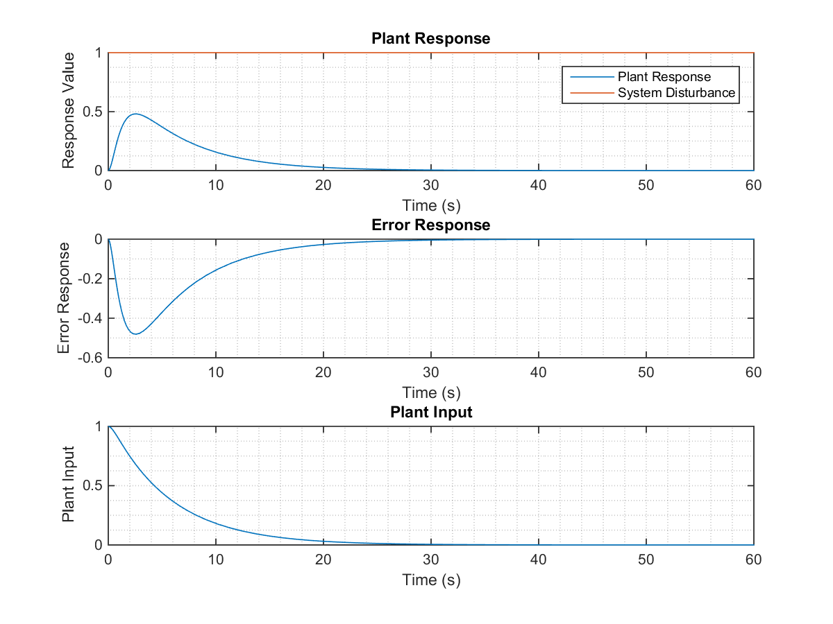

Figure 3.8. Parameters response for Proportional Integral Controller with Ki = 0.125.



Figure 3.9. Parameters response for Proportional Integral Controller with Ki = 0.25.

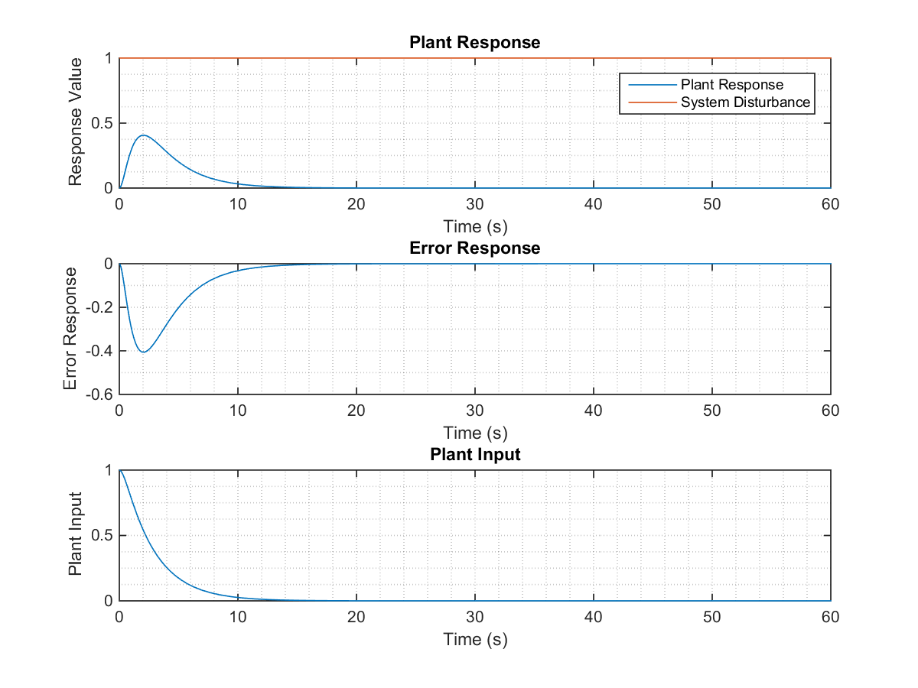

Figure 3.10. Parameters response for Proportional Integral Controller with Ki = 0.5.

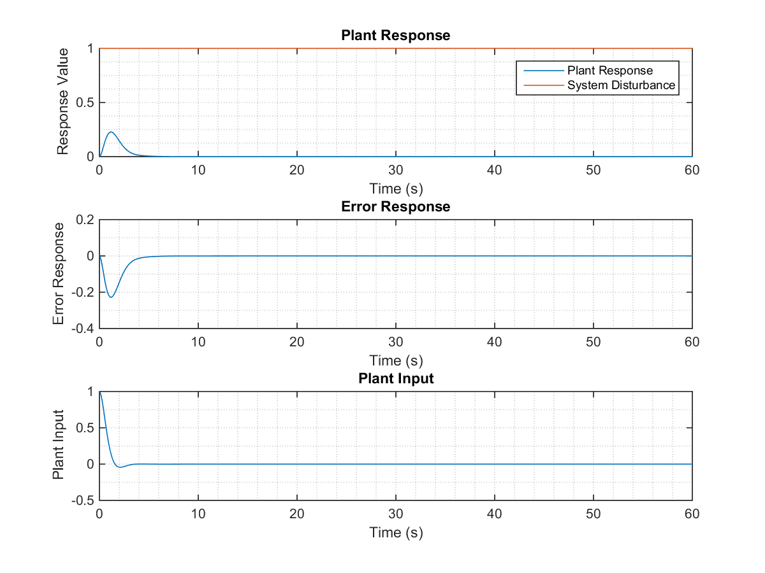

Figure 3.11. Parameters response for Proportional Integral Controller with Ki = 2.25.

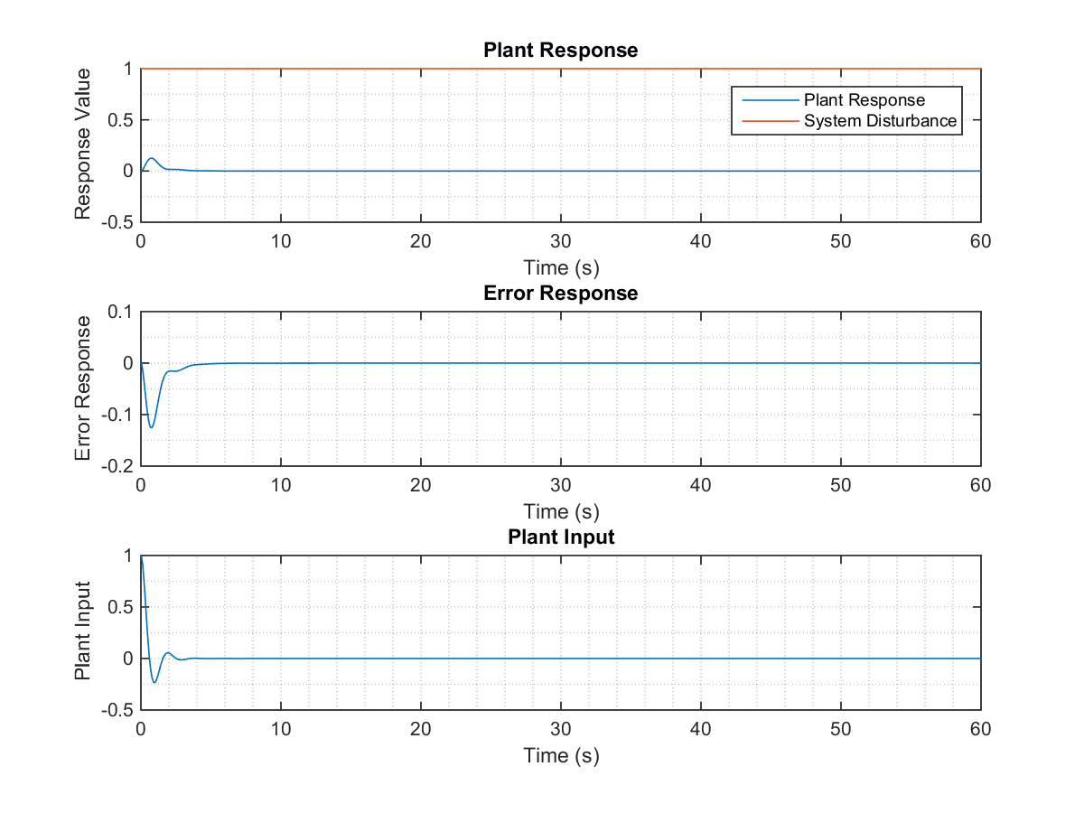

Figure 3.12. Parameters response for Proportional Integral Controller with Ki = 6.5.

ANALYSIS

For the responses obtained in Part 2, it is required to obtain some system parameters such as steady-state error (, rise time (, peak time ( percent overshoot (, settling time ( and steady-state value (.

For the settling time, we will use a 5% error band. This means that the settling time will be calculated when the system output oscillates between of its steady-state value.

Table 1. Parameters for Proportional Controller with no disturbance and unit step input.

|  |  |  |  |  |  |
| --- | --- | --- | --- | --- | --- |
|  |  |  |  |  |  |
| 0.125 | 0.9231 | 2.1692 | - | 3.8936 | 0.0768 |
| 0.25 | 0.8571 | 1.9807 | - | 3.5256 | 0.143 |
| 0.5 | 0.75 | 1.6790 | - | 2.9170 | 0.25 |
| 2.5 | 0.375 | 0.7597 | 4.3210 | 2.1082 | 0.625 |
| 6.5 | 0.1875 | 0.4098 | 16.2929 | 2.0190 | 0.815 |

Table 2. Parameters for Proportional Controller with no input and unit step disturbance.

|  |  |  |  |  |  |
| --- | --- | --- | --- | --- | --- |
|  |  |  |  |  |  |
| 0.125 |  |  |  |  |  |
| 0.25 |  |  |  |  |  |
| 0.5 |  |  |  |  |  |
| 2.5 |  |  |  |  |  |
| 6.5 |  |  |  |  |  |